**Project Design Phase-II**

**Data Flow Diagram &User Stories**

|  |  |
| --- | --- |
| Date | 14 October 2022 |
| Team ID | PNT2022TMID25025031 |
| Project Name | Personal Expense Tracker Application |
| Maximum Marks | 4 Marks |

**PERSONAL EXPENSE TRACKER APPLICATION: (Simplified)**

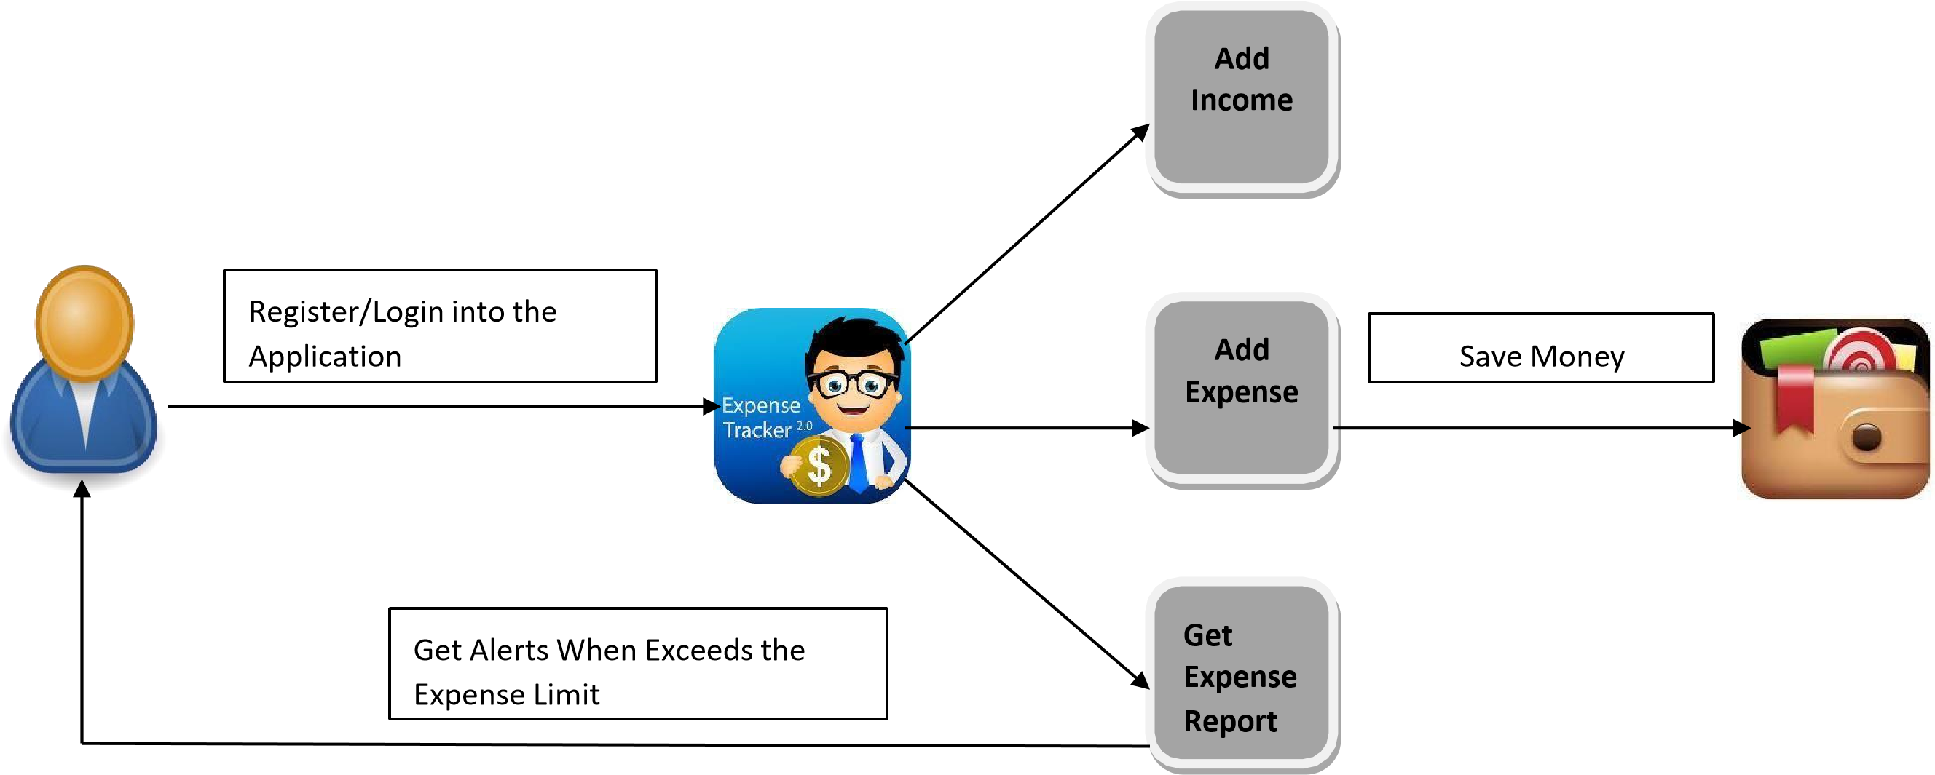

**DFD for PERSONAL EXPENSE TRACKER APPLICATION: (Industry Standard)**

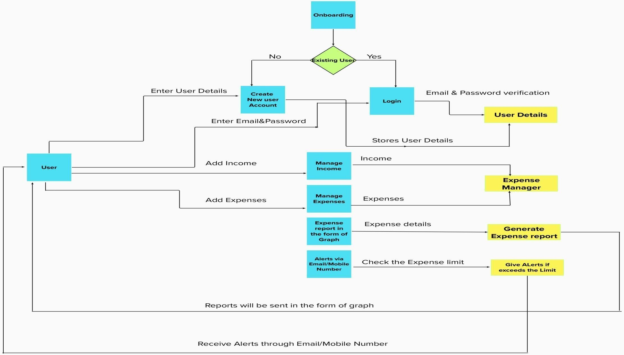

**User Stories**

|  |  |  |  |  |  |  |
| --- | --- | --- | --- | --- | --- | --- |
| **User Type** | **Functional**  **Requirement**  **(Epic)** | **User**  **Story**  **Number** | **User Story / Task** | **Acceptance criteria** | **Priority** | **Release** |
| Customer  (Mobile user) | Registration | USN-1 | As a user, I can register for the application by entering my email, password, and confirming my password. | I can access my account / dashboard | High | Sprint-1 |
|  |  | USN-2 | As a user, I will receive confirmation email once I have registered for the application | I can receive confirmation email & click confirm | High | Sprint-1 |
|  |  | USN-3 | As a user, I can register for the application through Facebook | I can register & access the dashboard with Facebook Login | Low | Sprint-2 |
|  |  | USN-4 | As a user, I can register for the application through Gmail | I can access the application | Medium | Sprint-1 |
|  | Login | USN-5 | As a user, I can log into the application by entering email & password | I can enter into the application by using the registered email and  password | High | Sprint-1 |
|  | Dashboard | USN-6 | As a user, I can enter into the dashboard to add my income and expenditures | I can view my daily, monthly and yearly expenses | High | Sprint-1 |
| Customer  Care  Executive | Alerts and Messages | USN-7 | As a Customer Care Executive, I can send Alerts and messages to the user | I can send alerts when the user exceeds the expense limit | High | Sprint-1 |
|  | Call Service | USN-8 | As a Customer Care Executive, I can also help out the customer at any part of time through the Customer Care Number  available in the application | I can help the user to clarify their doubts regarding the usage of application | Medium | Sprint-1 |
| Administrator | Application | USN-9 | As an administrator I can upgrade or update the application. | I can fix the bug which arises for the customers and users of the application | High | Sprint-1 |